**MongoDB Day 1**

1. **Find all the information about each products.**

db.products.find()

1. **Find the product price which are between 400 to 800**

db.products.find({product_price: {$gte: 400, $lte: 800}})

1. **Find the product price which are not between 400 to 600**

db.products.find({product_price: {$not: {$gte: 400, $lte: 600}}})

1. **List the four product which are greater than 500 in price**

db.products.find({product_price: {$gt: 500}}).limit(4)

1. **Find the product name and product material of each products**

db.products.find({}, {product_name: 1, product_material: 1, _id:0}).pretty()

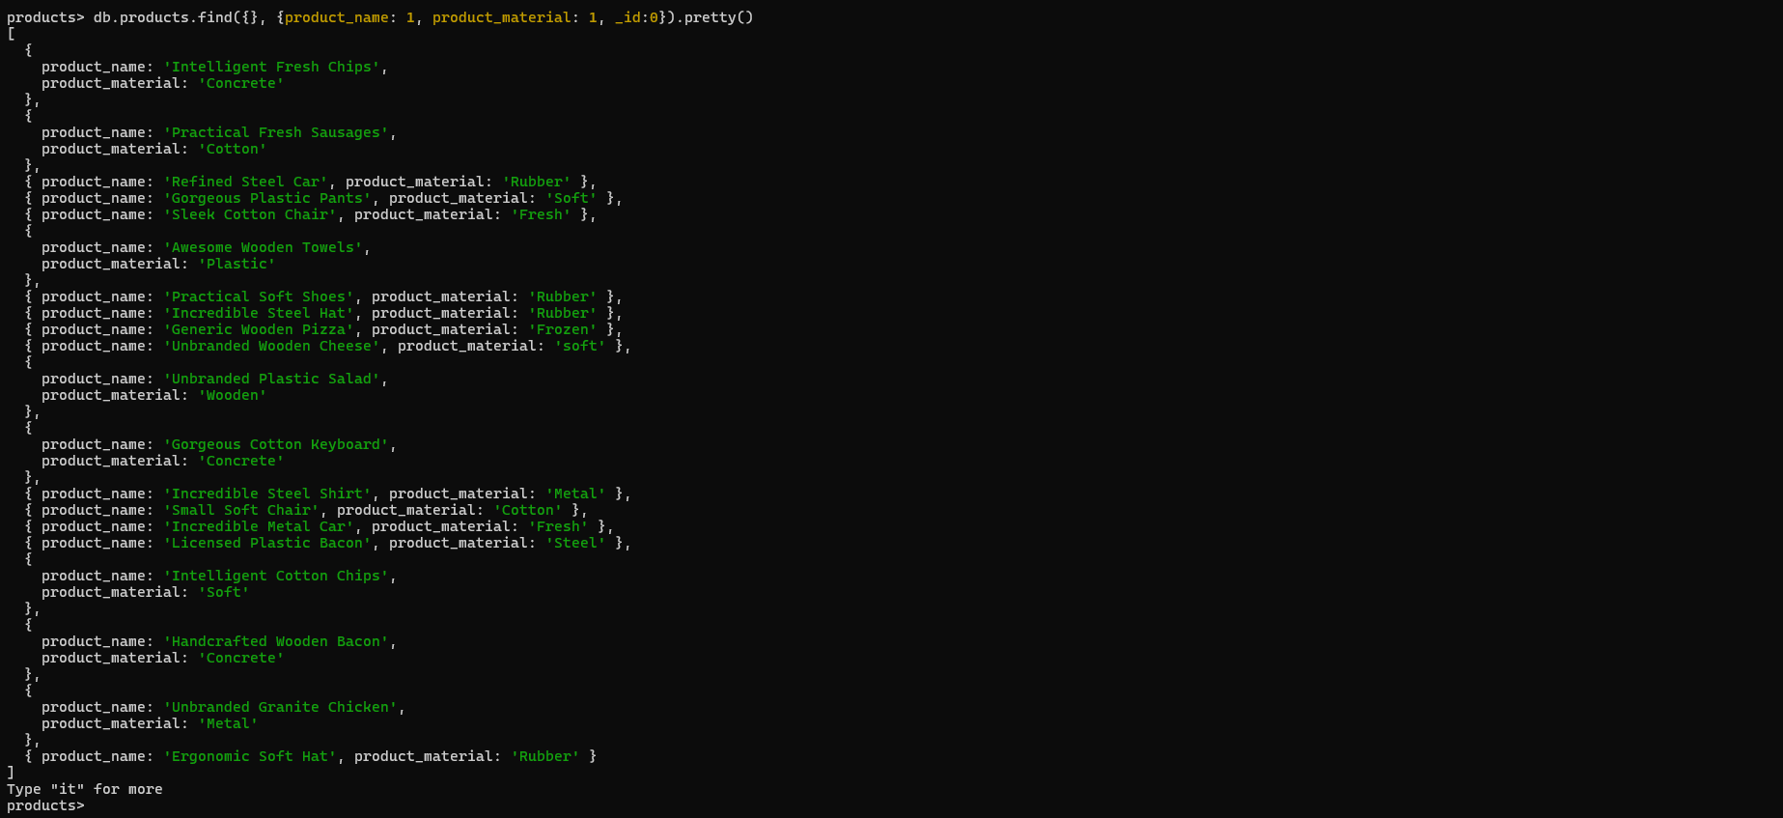

1. **Find the product with a row id of 10**

db.products.find({id: 10})

1. **Find only the product name and product material**

db.products.find({}, {product_name: 1, product_material: 1, _id: 0}).forEach(doc => {print(`Product Name: ${doc.product_name}, Product Material: $${doc.product_material}`)})

1. **Find all products which contain the value of soft in product material**

db.products.find({product_material: {$regex: /soft/i}})

1. **Find products which contain product color indigo  and product price 492.00**

db.products.find({$or: [{product_color: "indigo"}, {product_price : 492.00}]})

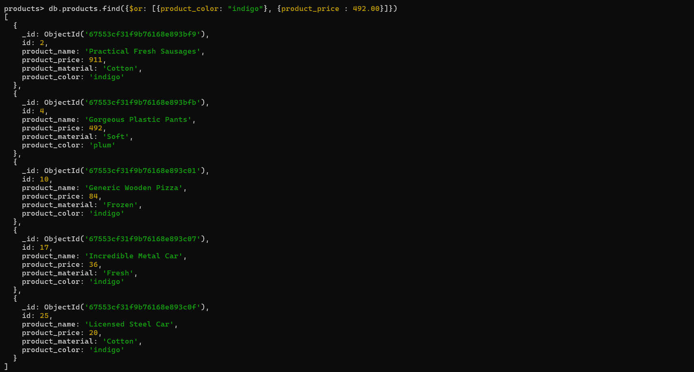

db.products.find({product_color: "plum", product_price : 492.00})

1. **Delete the products which product price value are 28**

db.products.deleteMany({product_price: 28})



The End!!!